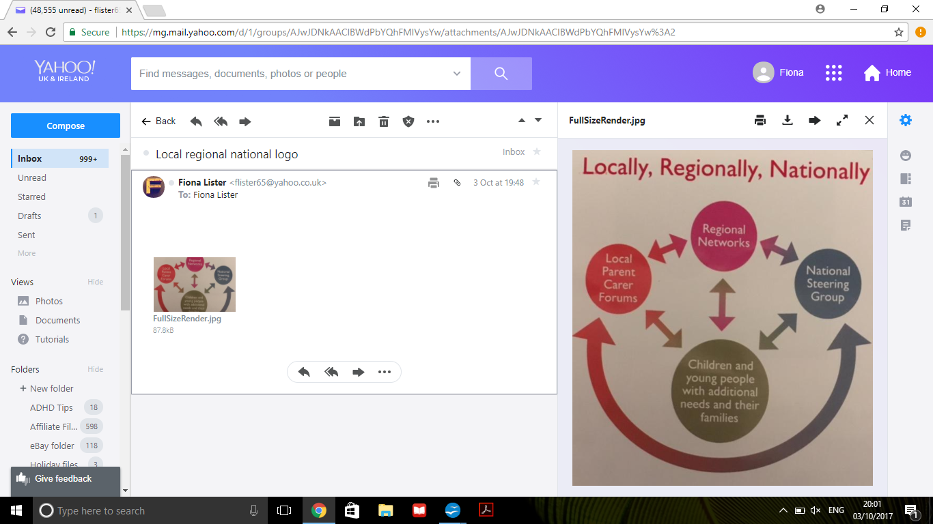  We work within South Tyneside with partners from education, health  and care sectors. The National Network of Parent/Carer Forums (NNPCF) is where our strength and shared experience is. We are  part of a 88,000 strong network of regional and national parents and carers. We influence strategic decisions in health, social and  education sectors. If you want more information please read: http://www.nnpcf.org.uk | 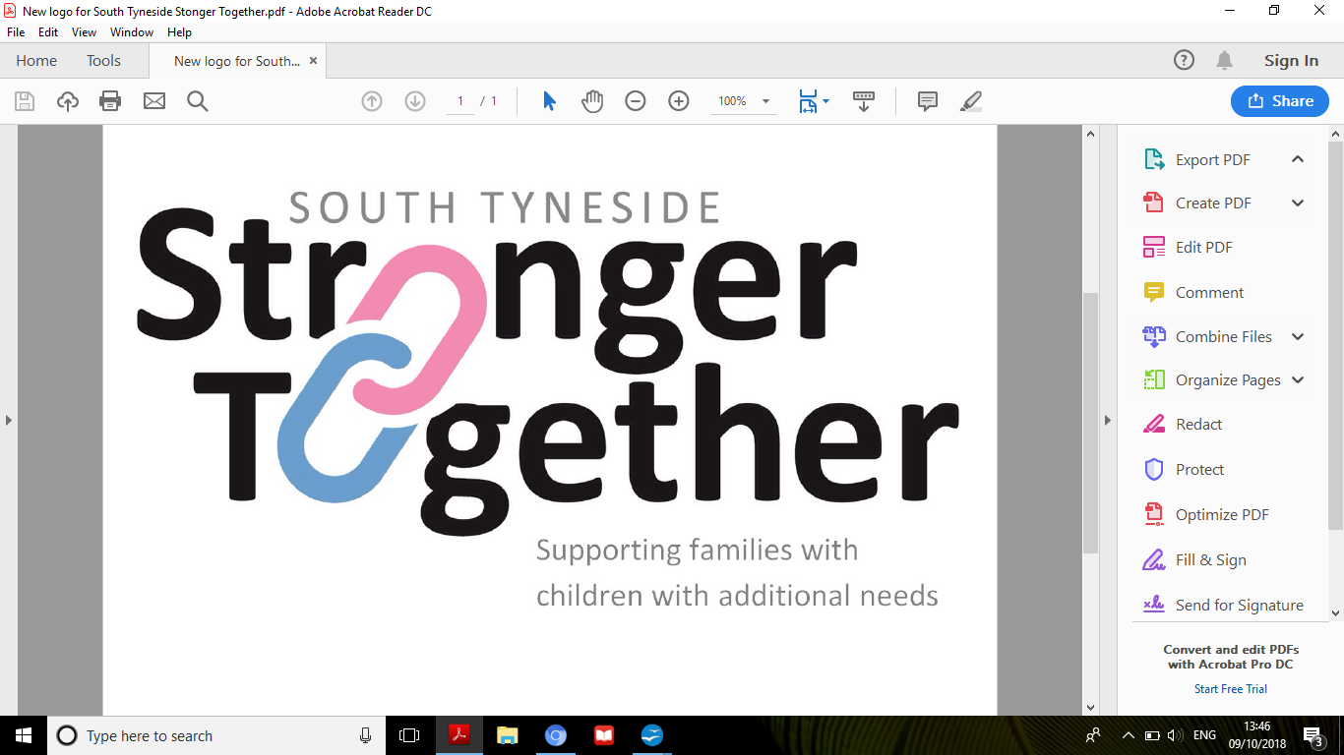  YOUR PARENT CARER FORUM  Supporting families with  children with additional needs  Working together to make  South Tyneside a more  inclusive place to live
  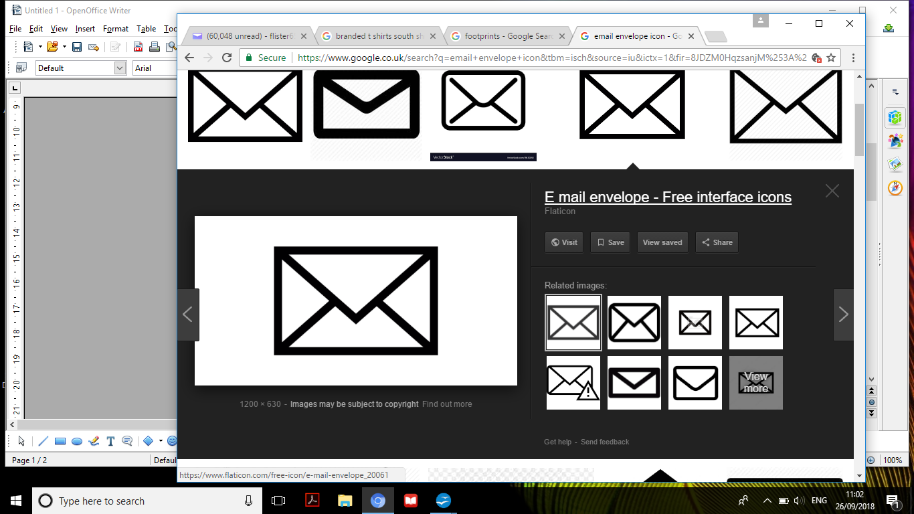 | c/o CGL at Adult Carers, Salvation Army Building, Wawn Street, South Shields, NE33 4EB
  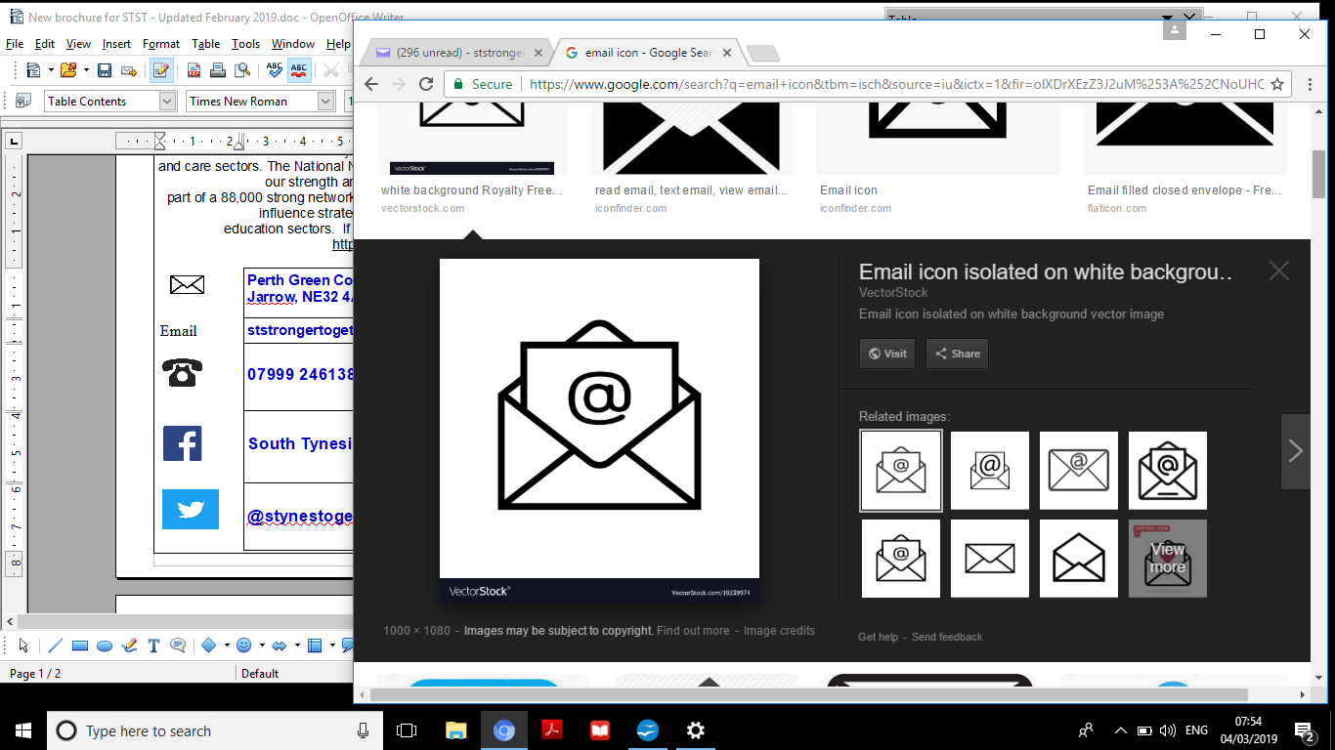 | ststrongertogether@yahoo.com
  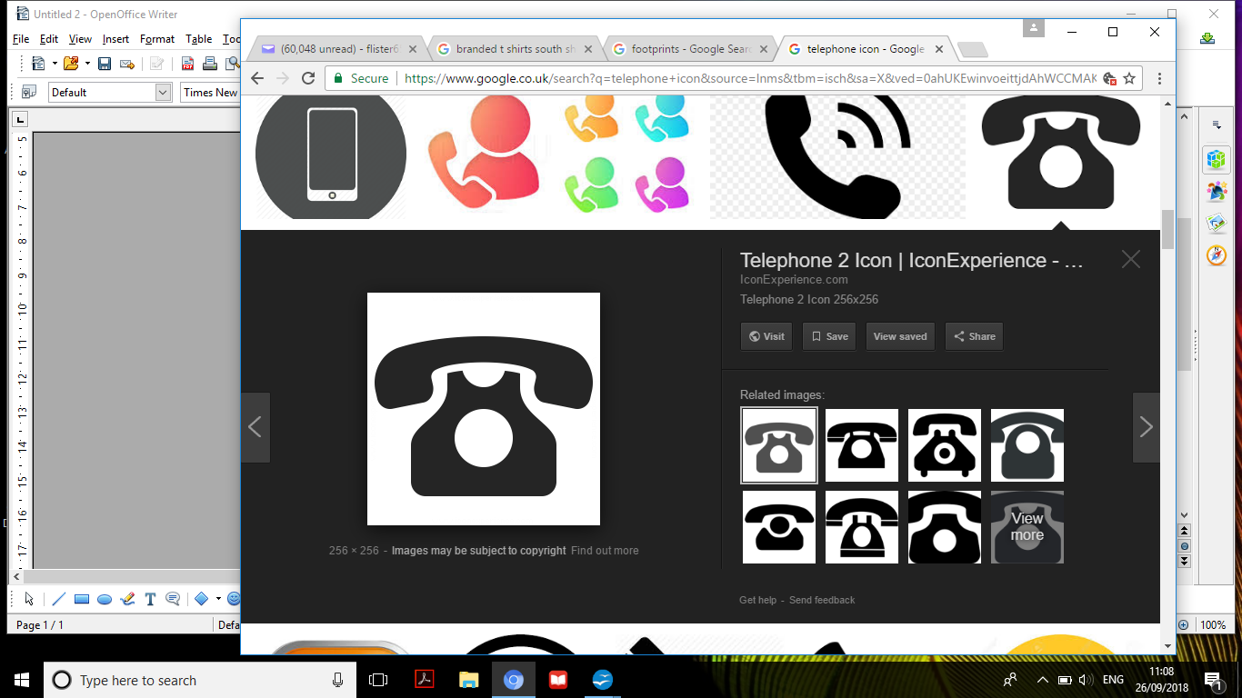 | 07999 246138
  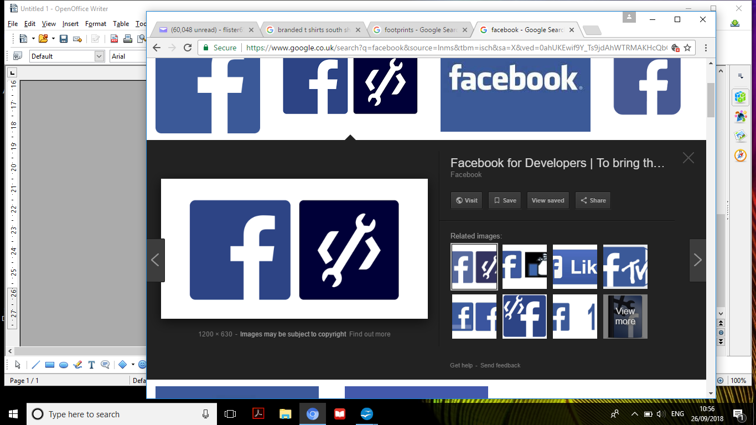 | South Tyneside Stronger Together
   | @ststogether2019
Our Aims  - We are inclusive to all parent/carers of children and young people with any additional needs aged 0-25 years.  - We aim to make a difference for those with additional needs.  - We welcome and value all parents/carers, so we can become a strong voice. We want to come together to share ideas and experiences, to promote positive thinking and bring solutions, that enable change.  - We will represent the views and aspirations of local families, to influence local statutory services.  - We want to promote the emotional well-being of families, by supporting each other, to learn and develop new skills and build a sustainable community.  - We want this because South Tyneside is Stronger Together  - A small team cannot change the world alone, but in the words of one of our children “lots of little steps leave a bigger footprint”.  - For more information on services available for children and young people with special educational needs and disabilities, please go to the Local Offer on this link:  https://www.southtyneside.gov.uk/article/37973/Local-Offer  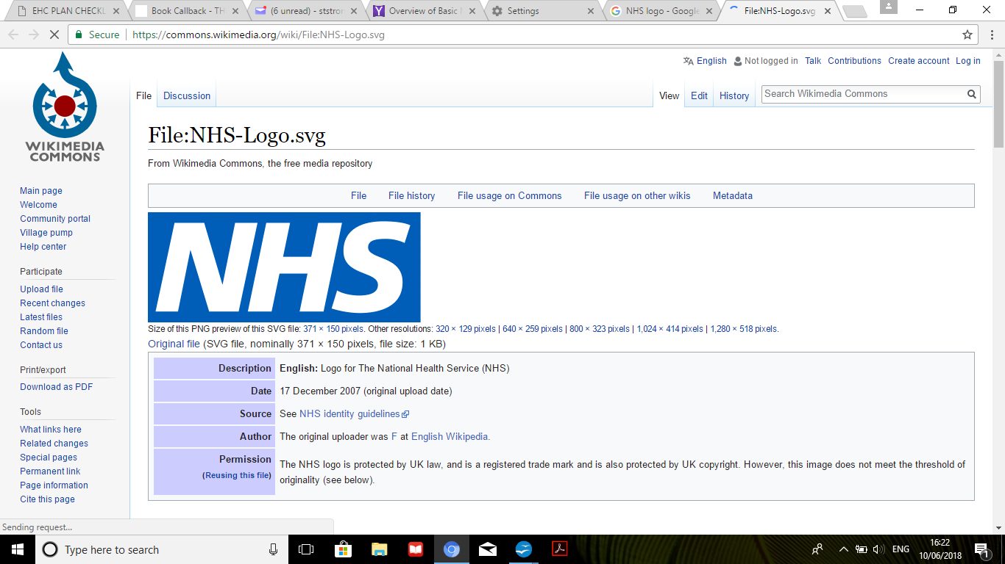  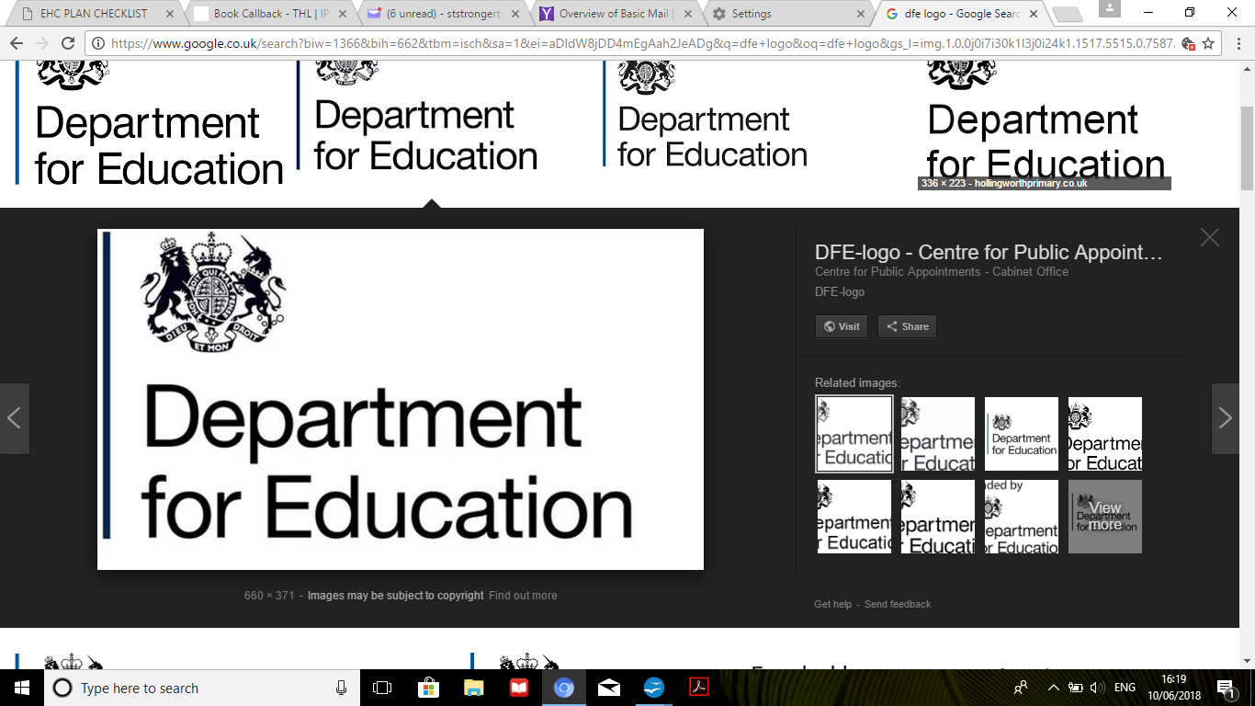  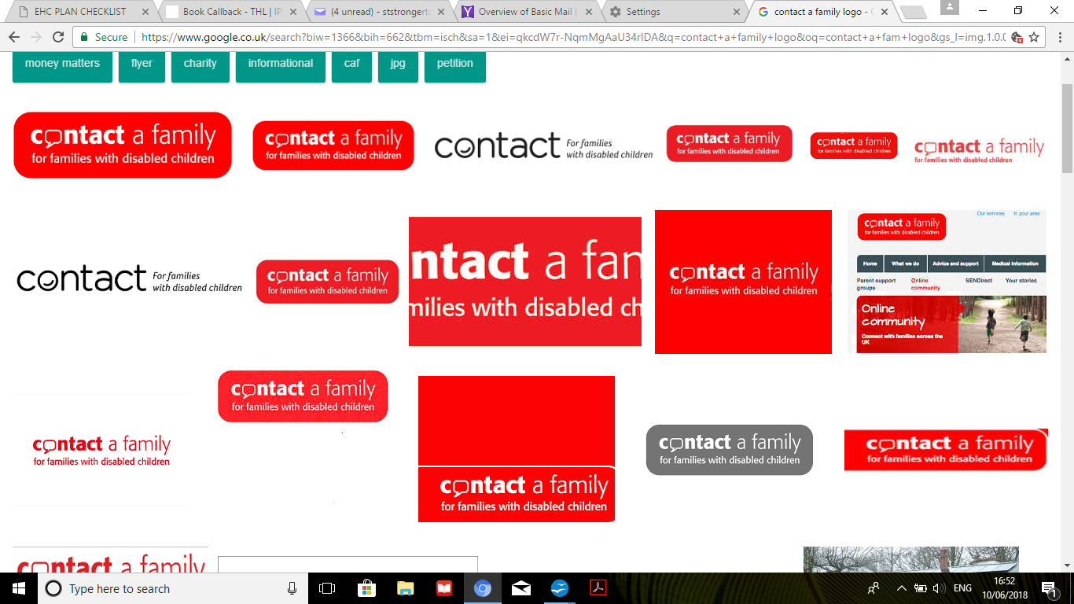  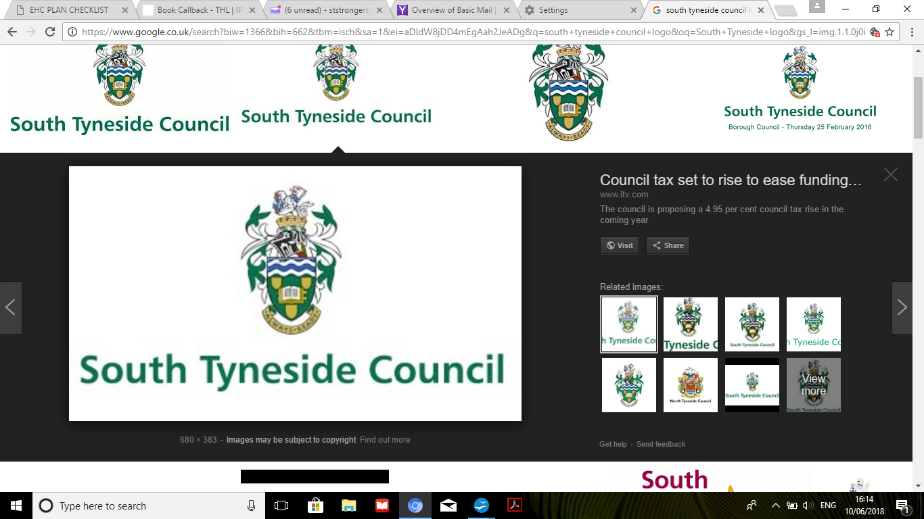  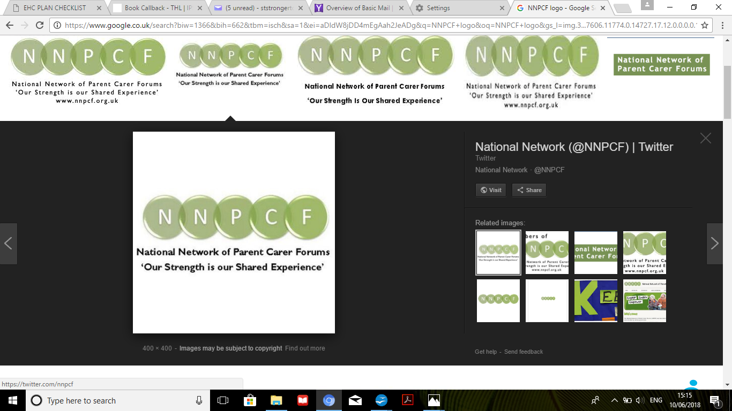 | Who are we?  South Tyneside Stronger Together  is your local Parent Carer Forum  Our steering group is made up of  parents and carers of children with additional needs.  We, the steering group are guiding it and our aim is to represent and support local families  with Special Educational Needs (SEN).  We are a voluntary organisation,  who work together with the local authority,  educational establishments and health care  providers, to ensure the strategies they are planning  to deliver will meet the needs of the children,  young people and their families living in  South Tyneside. We work under guidance from  Contact (formerly known as Contact a Family) who act a  mediator for funding from the Department of Education to enable us to carry out this work, but ultimately  … … … … …  We work for YOU!!

